How to install CV Certificate Viewer.

1. add a new environment variable with name ‘ CVCLASSPATH ‘ in system variables with lib folder i.e “G:\software\CV Certificate Viewer\lib\*” with quotes.

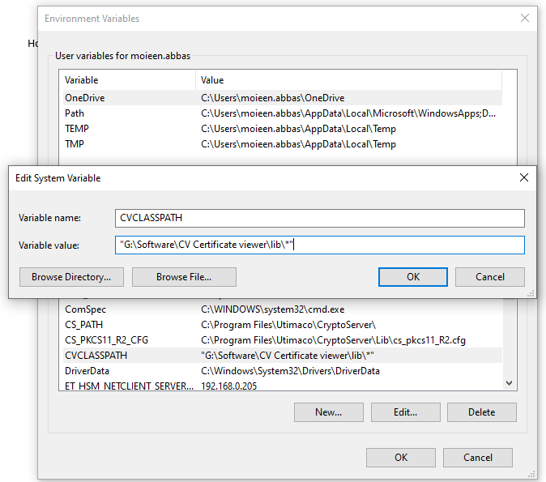

1. Set JAVA_HOME in ViewCVCertificate.cmd file
2. Edit cv_registry.reg file and replace text **CURENT_DIR** with directory where zip file is extracted.
3. To add option on right click menu run the cv_registry.reg with administration rights.

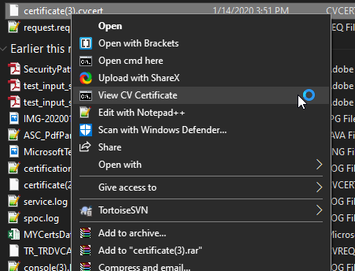

After this you see the right option when click on cv certificate.